This exam is open book / notes and worth a total of 50 points. It must be submitted through Blackboard by 12:40 p.m. on November 15, 2017.

Save each problem in a script named lab02.sql. Include a comment with your name in the script, along with comment before each solution.

Upon completion, submit your script as an attachment to the Lab Exam 2 assignment in Blackboard.

NOTE:Use the same formatting features and column headings as shown in the sample output.

Problem 1

Display the title, category, publish date and retail price for each book.

Sort the output by title in alphabetical order.

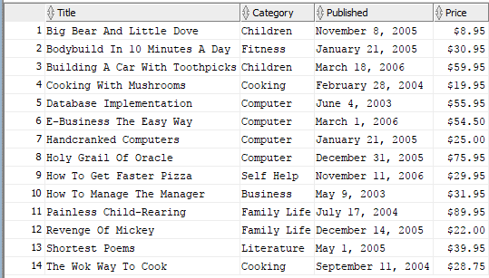

Problem 2

Display the ISBN, title and publisher’s name for each book in the Computer category.

Sort the output by ISBN in ascending order.

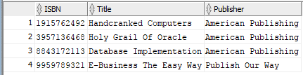

Problem 3

Display a list of customer #’s that have not placed an order.

Sort the results by customer# in ascending order.

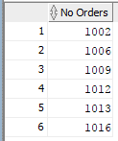

Problem 4

Display the order #, customer name, order date and ship date for all orders that have been shipped.

Sort the results by order # in ascending order.

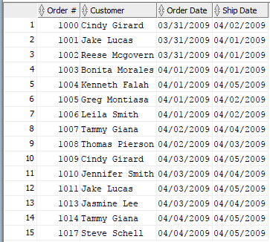

Problem 5

Display a list of all customers, along with the name of the customer that referred them.

If a customer was not referred, display the literal N/A.

Sort the results on the customer’s last name.

